Project Information
Site : Construction of 564 MLD (124 MGD) WWTP OKHLA DELHI

Project Address : 564 MLD (124 MGD) Waste Water Treatment Plant, C/o Delhi Jal Board, Okhla Disposal Area , Jasola Vihar , New Delhi 110020

Contact Details

Project Director : Mr. Dushyant Sharma – 9899037873

Project Manager : Mr. Avinash Kumar -- 9964568781

Site Office Contact Number :

Email Id : Sharma, Dushyant dushyant.sharma@suez.com

Contract : DBO OF Waste Water Treatment Plant

Contract No- C.A NO. 01 (2019-2020)
Type of contract (result / average): Construction Of 564 MLD (124 MGD) WASTE WATER TREATMENT PLANT WITH STANDARD OF BOD-10 mg/l, TSS -10mg/l or better and power generation on DBO basis at Okhla under YAP (III) (Package ‘O’) C.A NO. 01 (2019-2020) by SUEZ INDIA PVT. LTD. – SUEZ INTERNATIONAL JV

Description of the Contract - :

Description of Plant -:

Okhla gets India’s largest sewage treatment plant which will treat 56.4 crore litres of WASTE WATER per day

Background:
At present Okhla Sewage Treatment complex comprises of six existing STPs, namely Phase-I (136 MLD), Phase-II (55 MLD), Phase-III (205 MLD), Phase-IV (168 MLD), Phase-V (73 MLD) and Phase-VI (136 MLD). The existing Phase-I, II, III and IV STPs were constructed in the year 1937, 1982, 1991 and 1993 respectively with effluent parameters of BOD < 30mg/l and TSS < 50mg/l. As the old plants have outlived their useful life, a new STP of combined capacity of Phase I, II, III & IV (136+55+205+168) = 564 MLD (124 MGD) shall be constructed with stringent effluent parameters of BOD < 10 mg/l & TSS < 10 mg/l including removal of Biological Nutrients.
The plant will be the biggest plant ever built in India. After construction of this 564 MLD STP, the effluent parameters shall be improved from existing BOD < 30mg/l & TSS < 50mg/l to BOD & TSS < 10mg/l with Nitrogen & Phosphorus removal and Fecal Coliform reduction to <230MPN/100ml, which will ultimately improve the water quality in river Yamuna.
Salient features of the plant will be :
- The wastewater will be treated to BOD & TSS < 10 mg/l with Nitrogen &
- Phosphorus removal.
- Provision of Tertiary filters and Ultraviolet (UV) disinfection.
- Online stage wise monitoring of all the effluent parameters.
- Sludge handling facilities like digesters with generation of Class A Sludge.
- Provision of membrane type gas holders to hold the produced biogas efficiently.
- Provision of power generation from biogas to make the plant self-sustainable to a great extent.
- Provision of mechanical dewatering of sludge instead of sludge drying beds resulting in saving of huge land area.
- Fully automated based on SCADA system.
- Development of Sludge Management Facility.
- No disruption in the operation of existing treatment plants during the construction of new STP as the plant will be constructed at a vacant additional available land.
DB works consist of
- Demolition of existing phase I, II, III & IV WWTP. Phase I structures need to be demolished now for the construction of 564 MLD WWTP & rest of the phases shall be demolished after construction of new plant since they are currently functional
- Construction of 564 MLD capacity WWTP with UV disinfection before gravity disposal in Yamuna river drain
- 4.8 MW Power Cogeneration (Biogas Engines)
- Central cooling system along with cooling towers for major buildings such as Power Generation Building, Air Blower Building and Substation Building
- Solar sludge drying system with dryness of 55-65%

O&M Works
- 11 Years Comprehensive Operation and Maintenance
(1 Year DLP + 10 Years O&M)

Total Plant Area - Total Plant Area : -114.128 acres.

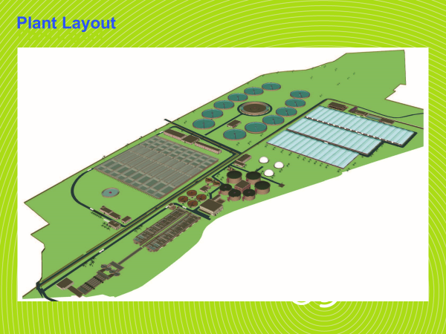

List of Contractors work

- CELESTA INFRAPROJECTS PVT. LTD.
( Head Office)
A-65, ASHOK VIHAR PHASE 2
NEW DELHI -11—52
Contact Number – 9810006026

LOI REF NUMBER: 1586/T0500/LOI-01/TO505/Excavation work

- M/s ISGEC Heavy Engineering Limited
A-4, Sector -24, Noida – 201301

Contact Number – 9790910213
LOI REF NUMBER : 1586/TO500/LOI-006/T0506/CIVIL WORK

- QUESS CORP-DELHI
Near Badarpur Industrial Estate
B-1/I-1, First Floor, Mohan Industrial Estate
Delhi -110044

Contact Number – 9990675995

- M/s FRONTIER CIVIL CONSTRUCTION
PANJABI BAGH DELHI
LOI REF NUMBER : / DEMOLITION WORK

Contact Number – 8218761141

